Swavy Dispatch – How to Use
Motorcycle (okada) parcel delivery for Lagos and Abuja, with a Telegram booking bot.

What it does
- Customers book a bike in 3 steps and see an instant price (zone table + size + optional Express).
- Pay: cash at pickup, cash on delivery or transfer (simulated). Optional Collect money for me.
- Live tracking page with rider photo, name, plate and a simple map; share on WhatsApp; rate the rider.
- Riders: Go online/offline, jobs near you, one-tap accept, status steps, pickup photo, delivery only with the receiver's 4-digit code, earnings and cash in hand.
- Dispatcher/admin: live orders, assign riders, verify riders, edit prices, track cash.
- Telegram bot for booking and tracking by chat.

How to open it on Windows
1. Open the swavy-dispatch folder.
2. Double-click start.bat.
3. Your browser opens http://localhost:3002 (next free port if busy).
4. Keep the black window open.

Demo logins
Who | Email | Password
Customer (Lagos) | customer@swavy.ng | swavy123
Rider (Lagos, Yaba) | rider@swavy.ng | swavy123
Rider 2 (Lagos, Lekki) | rider2@swavy.ng | swavy123
Dispatcher / admin | open http://localhost:3002/#/admin | swavyadmin

Extra sample accounts (password swavy123): rider3@swavy.ng (not verified yet), rider.abuja@swavy.ng, customer.abuja@swavy.ng.

Step by step

Customer: send a package
1. Log in as customer@swavy.ng.
2. Enter pickup area and address, then drop-off area and address.
3. Choose size, what it is, and the receiver's name and phone. Add Express if you want.
4. Check the price and confirm. Share the tracking link and code with the receiver on WhatsApp.
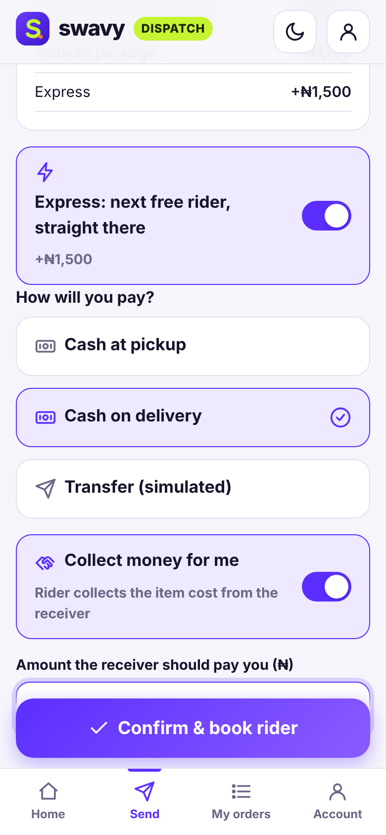
Instant price before you confirm

Rider: deliver
1. Log in as rider@swavy.ng and tap Go online.
2. Accept a job from Jobs near you.
3. Follow the steps: Heading to pickup → Picked up (take a photo) → On the way.
4. At the door, enter the receiver's 4-digit code to mark it Delivered.
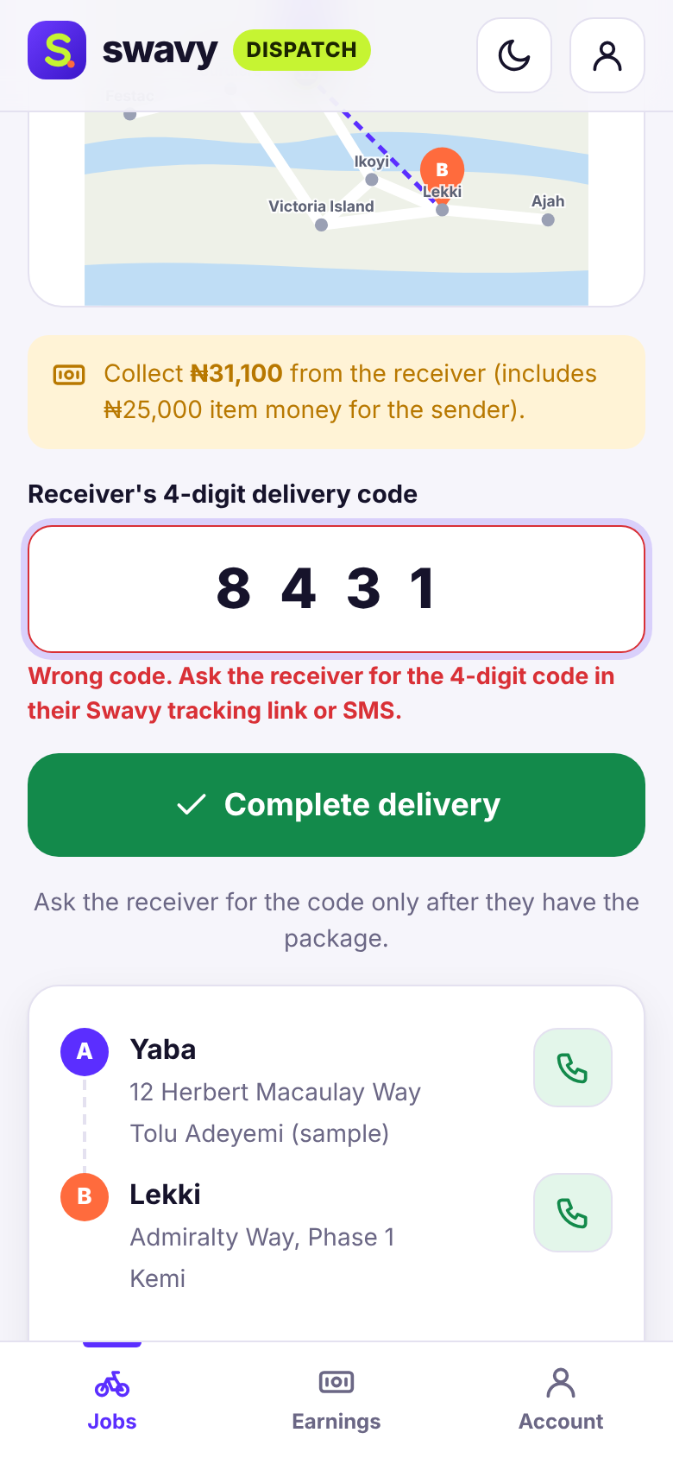
Rider enters the receiver's code

Admin
Open #/admin with password swavyadmin to assign riders, verify riders, edit prices and mark cash received.
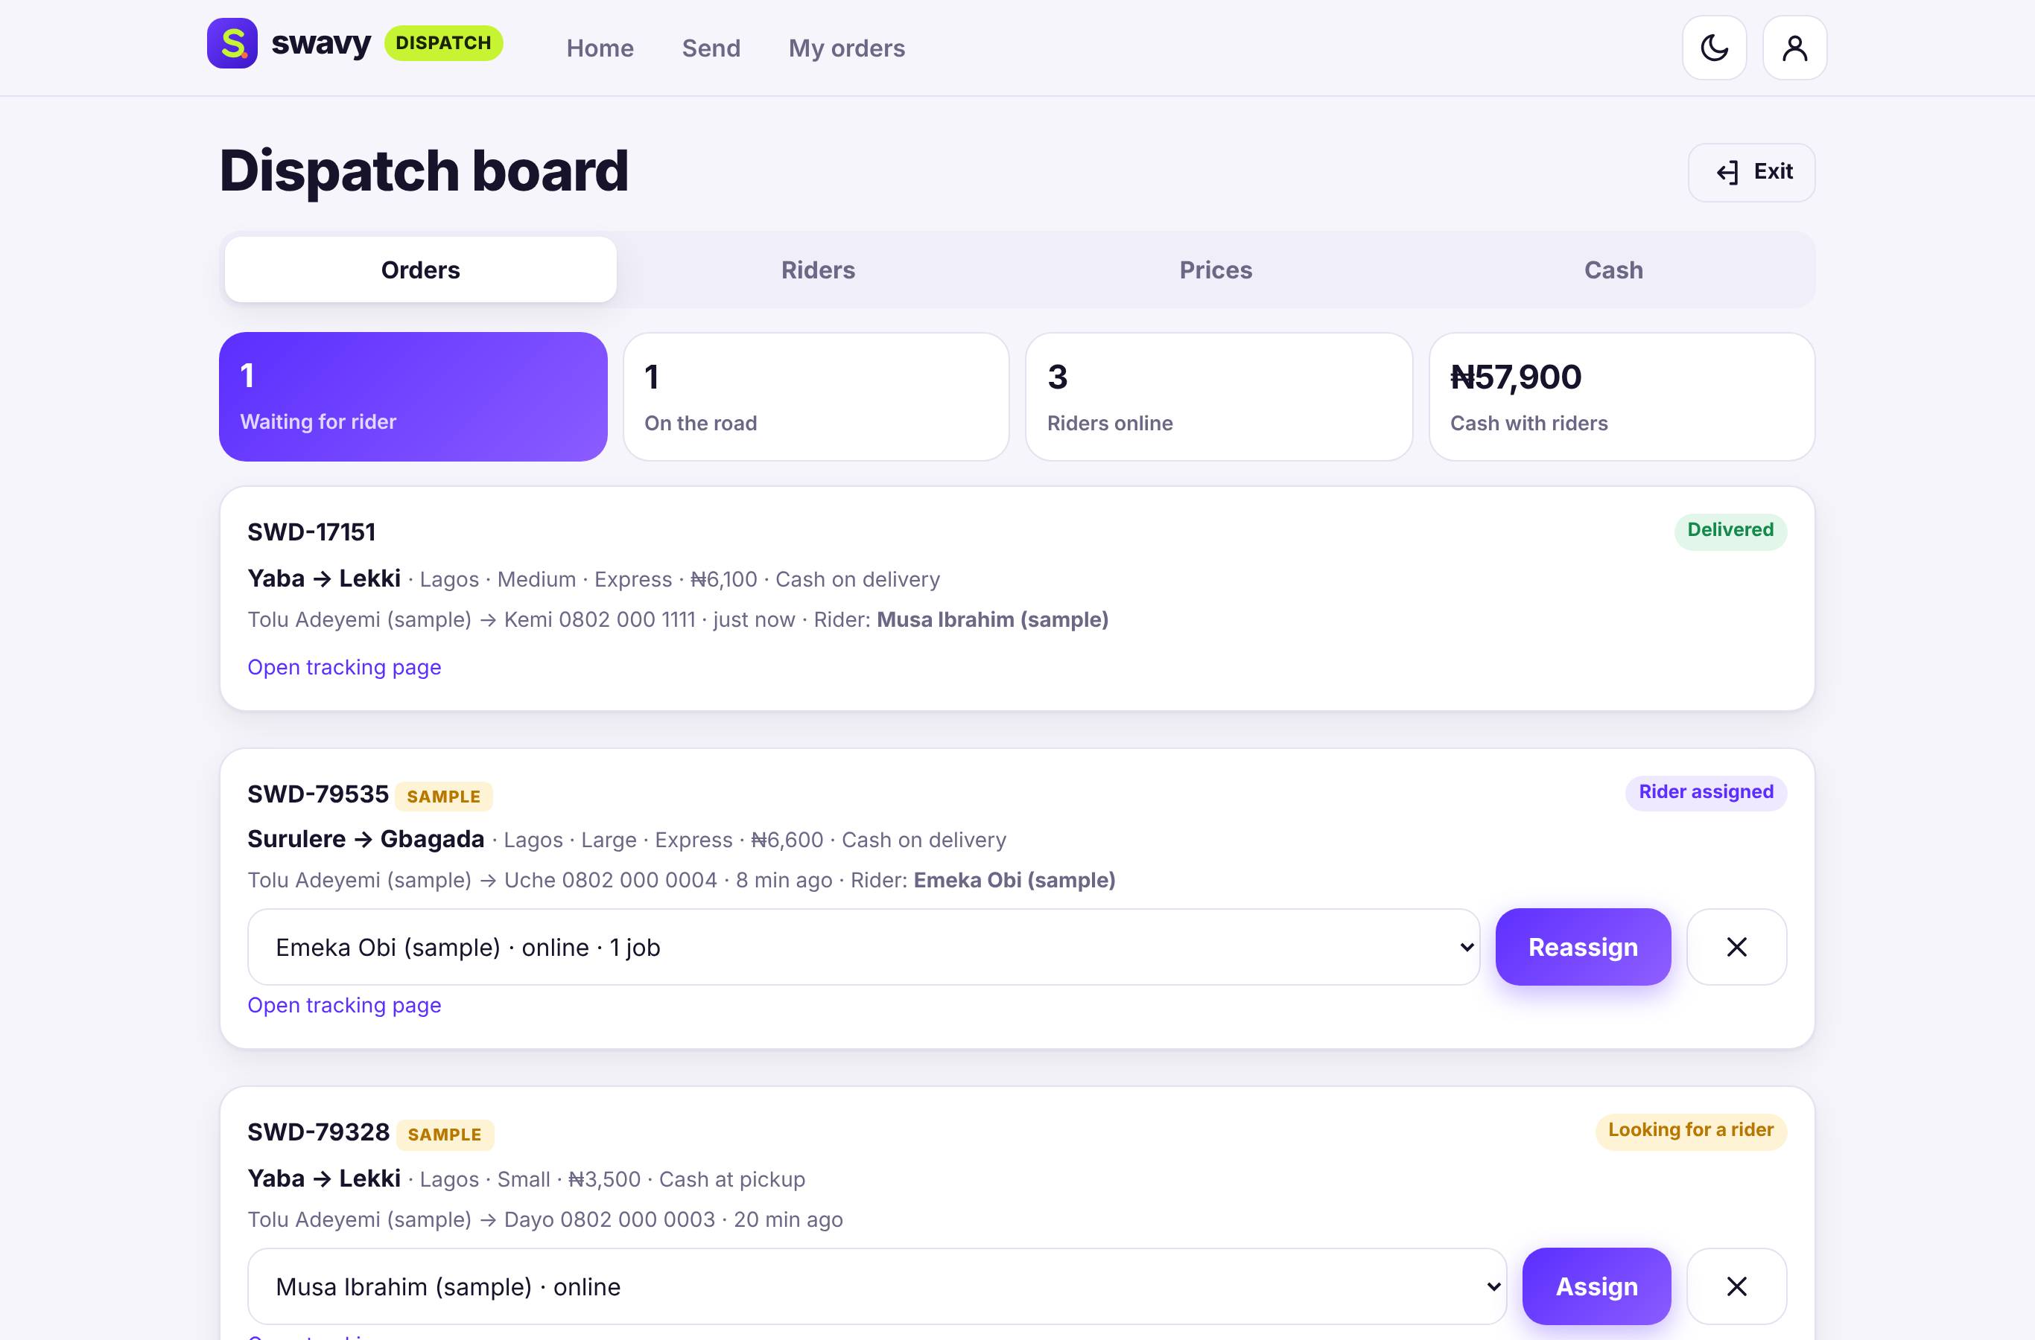
Dispatcher view

Telegram bot

Try it without Telegram
Open http://localhost:3002/bot-test. It looks like a Telegram chat and runs the same bot. Orders made there are real orders in the app.

Put the real bot on Telegram (about 3 minutes)
1. In Telegram search for @BotFather (blue tick).
2. Send /newbot.
3. Type a name, e.g. Swavy Dispatch.
4. Type a username ending in "bot", e.g. SwavyDispatchBot.
5. Copy the long token it gives you (looks like 123456789:AAH...). Keep it secret.
6. In the swavy-dispatch folder copy .env.example and rename the copy .env. Open it in Notepad.
7. Paste the token after TELEGRAM_BOT_TOKEN= and save.
8. Close the black window and run start.bat again. It should say "Telegram bot: @YourBot is live".
9. Open your bot in Telegram and send /start.
Commands: /start, /book, /track SWD-12345, /price, /cancel. The bot only runs while the app is running and your computer is online. Tracking links are only clickable from other phones once the app has a public address (PUBLIC_URL in .env).

Your data and the database
Everything is saved in one file: data\swavy-dispatch.db inside the Swavy Dispatch folder. It is created the first time you start the app.

Look inside
- Open a Command Prompt in the folder (click the address bar in File Explorer, type cmd, press Enter) and type npm run db to list every table and how many rows it has.
- Type npm run db -- orders to see the latest rows of one table.
- Or install the free DB Browser for SQLite (https://sqlitebrowser.org) and open the .db file. Stop the app first.

Start fresh (reset)
1. Close the black window to stop the app.
2. Delete the data folder inside the project folder.
3. Double-click start.bat again. The sample data is created again.

Troubleshooting
Problem | What to do
The black window says "Node.js ... was not found" | Install Node.js 24 LTS from https://nodejs.org, restart the computer, then double-click start.bat again.
Port 3002 is busy / another app is open | Close the other black window (or the other app) and try again. The app tries the next free port automatically – read the address printed in the black window and type it into your browser.
The browser did not open | Open Chrome or Edge yourself and go to http://localhost:3002 (or the address shown in the black window).
The page will not load | Make sure the black window is still open. Closing it stops the app.
Windows SmartScreen / firewall warning | Click "More info → Run anyway" for start.bat. If asked about the firewall, choose Private networks.
Telegram bot not answering | Check the token in .env, restart start.bat, keep the window open and the computer online.

Honest limitations
- Payments are simulated – cash is tracked but no money moves through the app.
- Areas, zones and prices are samples (edit them in admin).
- The map is a simple drawing and the bike movement is simulated – no real GPS.
- No SMS is sent; receivers get their code by WhatsApp share or the tracking link.
- Delivery is within one city at a time.

